**Sales Insights**

1. **KPI’S :**

* Total Sales : $2.29 M
* Total Profit : $37.8 K
* Total Quantity : $286 K
* Total Orders : 4991
* Average Order Value : $460
* Total Customer : 2499



1. **Sales by Category :**

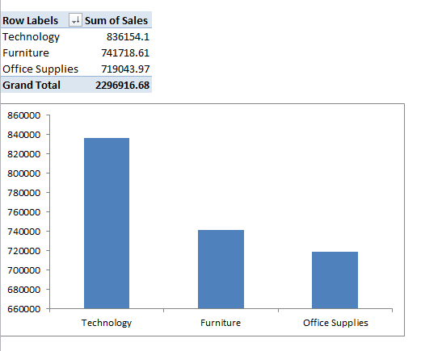

1. **Profit by Category :**

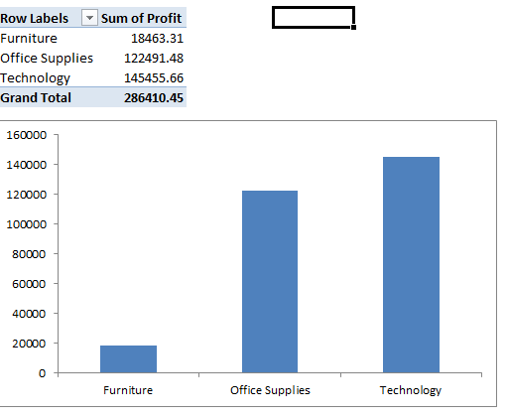 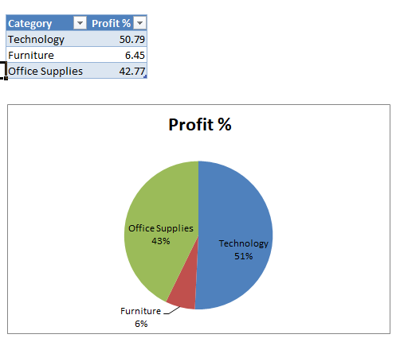

1. **Sales & Profit by Sub-category :**

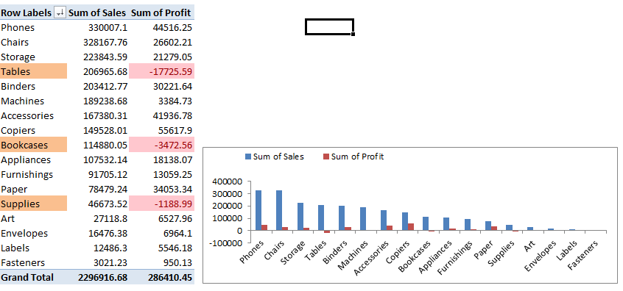

1. **Yearly Trend :**

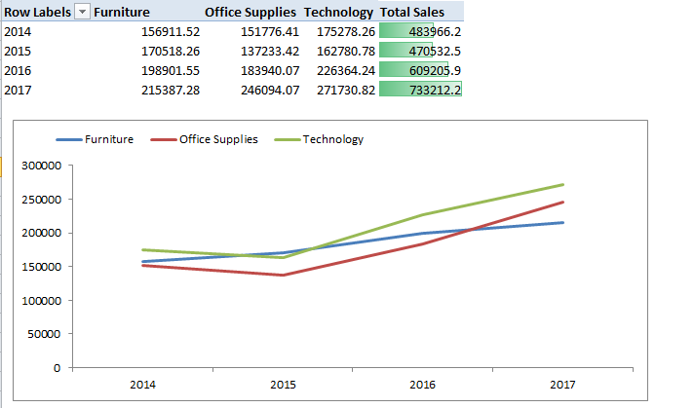

1. **Monthly Trend :**

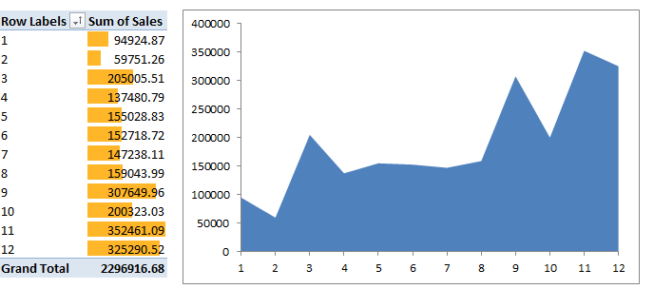

1. **Top & Bottom 5 States on the basis of sales :**

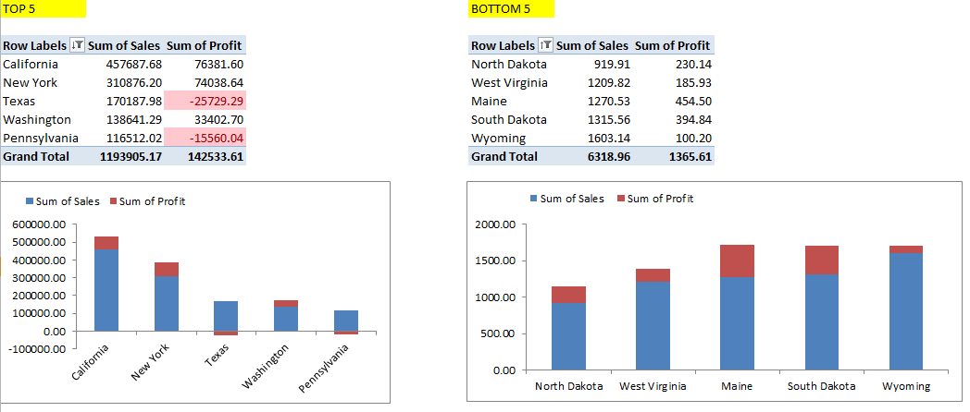

1. **Top & Bottom 5 Customers on the basis of Profit :**

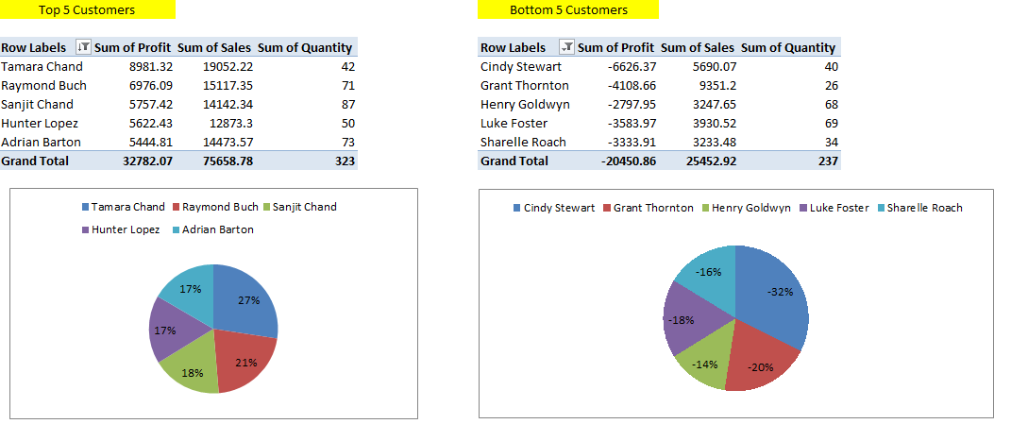

1. **Total Customers :**

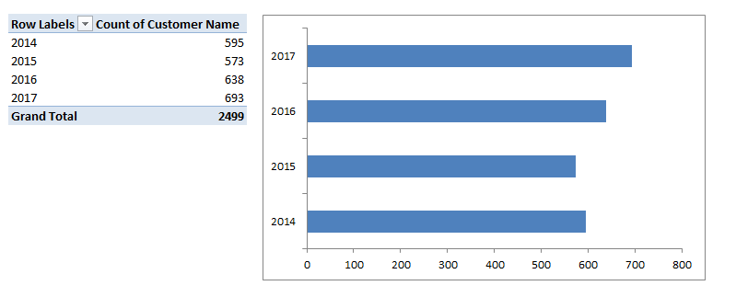

1. **Sub-categories in Losses:**

